IAM (identity access management)

Very important for any role

It is AWS security service

Here permissions are attaching and detaching

Default polies 1258 given by AWS

In this case, it will give full or no access

To avoid this we go with custom access by ANR (Amazon resource names)

IAM user is a temporary access user

From root account if you create a user account, that is IAM account

Root can control the IAM user at any time

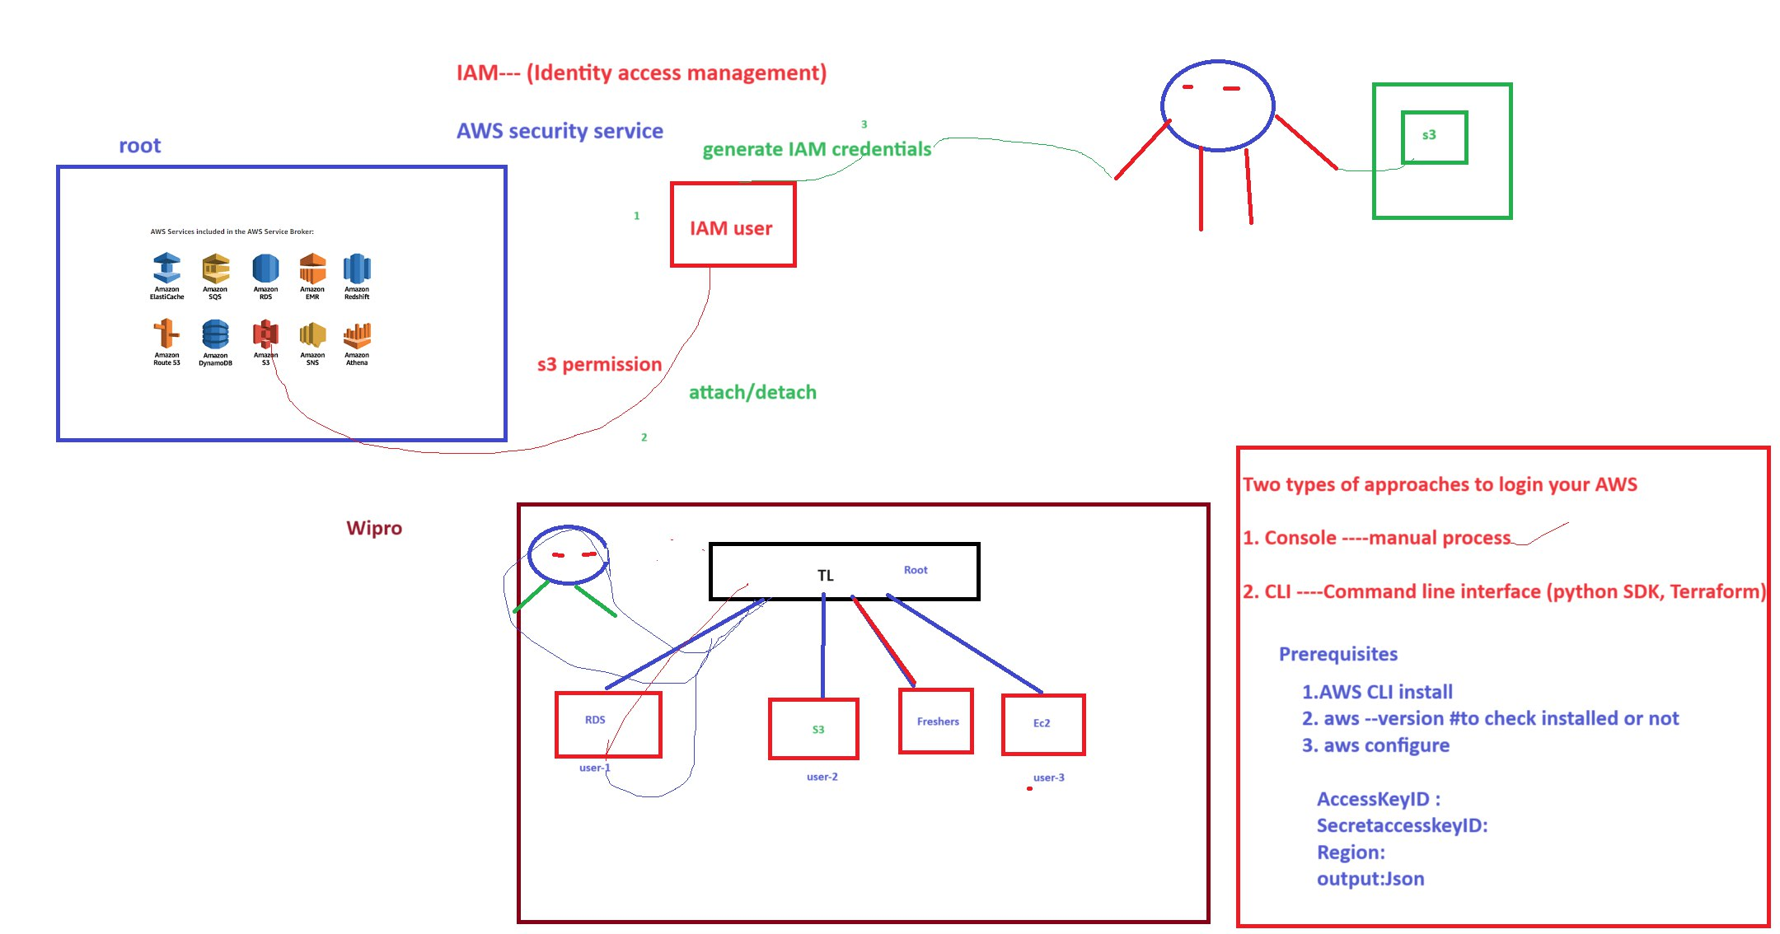

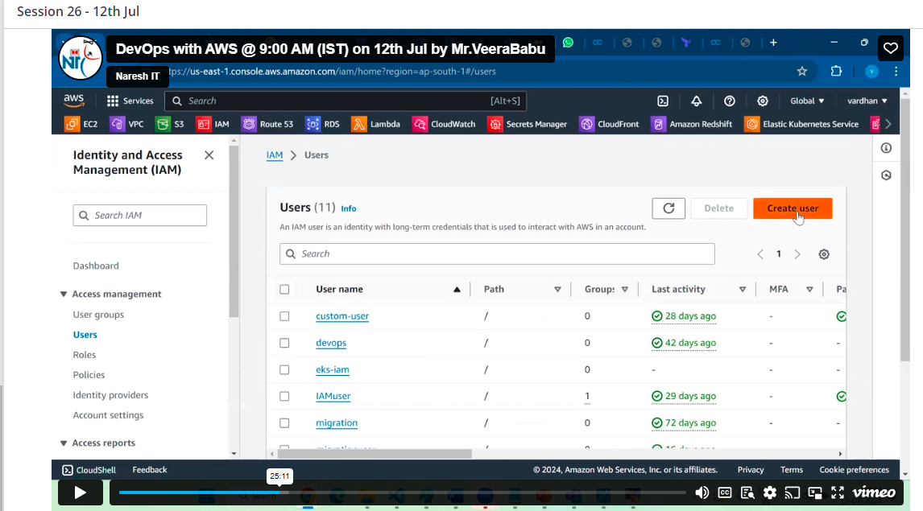

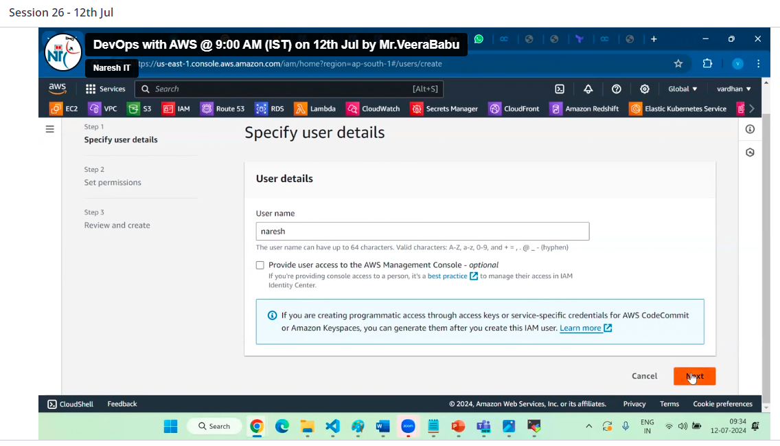

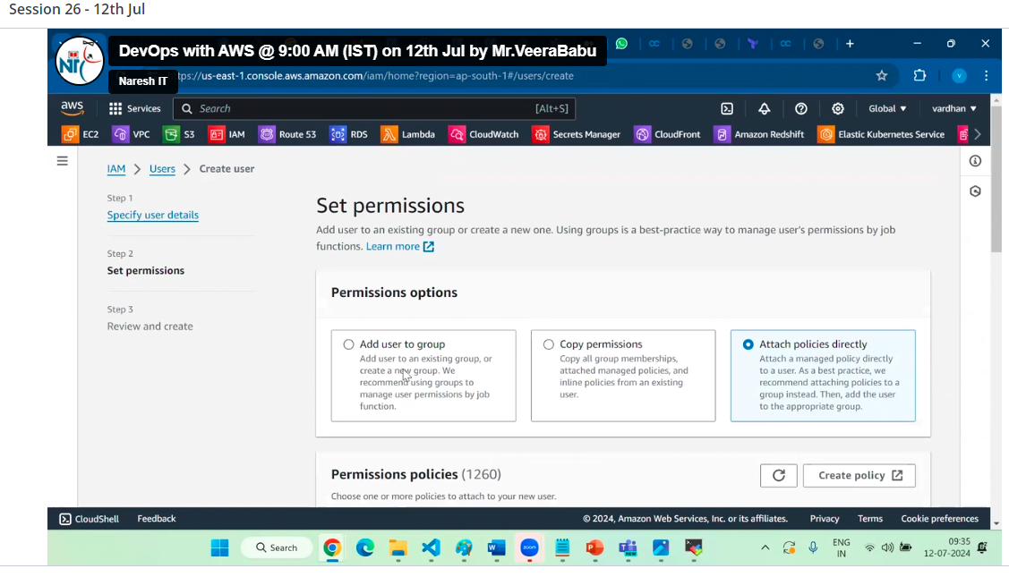

Select the policies that requires and click on create user

Now IAM user created and permissions are given then need security credentials

Here we have 2 types of credentials

1. Console ---Manual process (UI—user interface)
2. Command line interface (CLI)

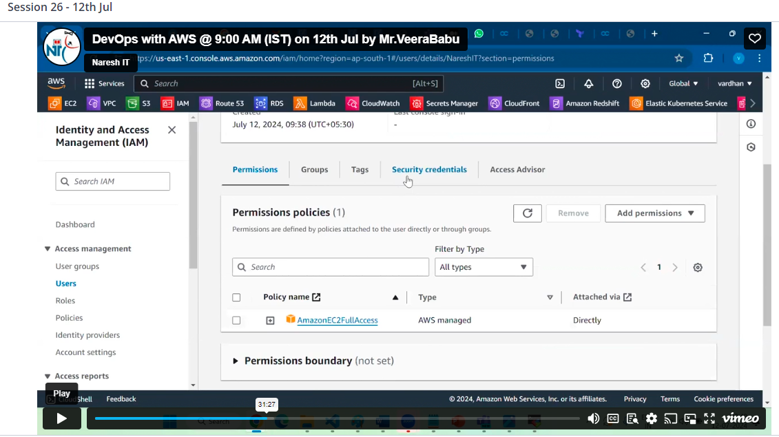

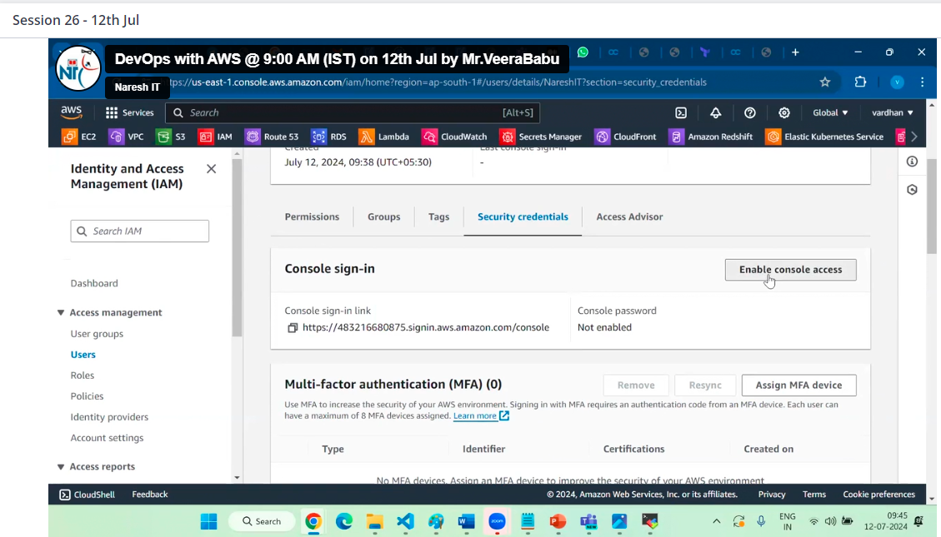

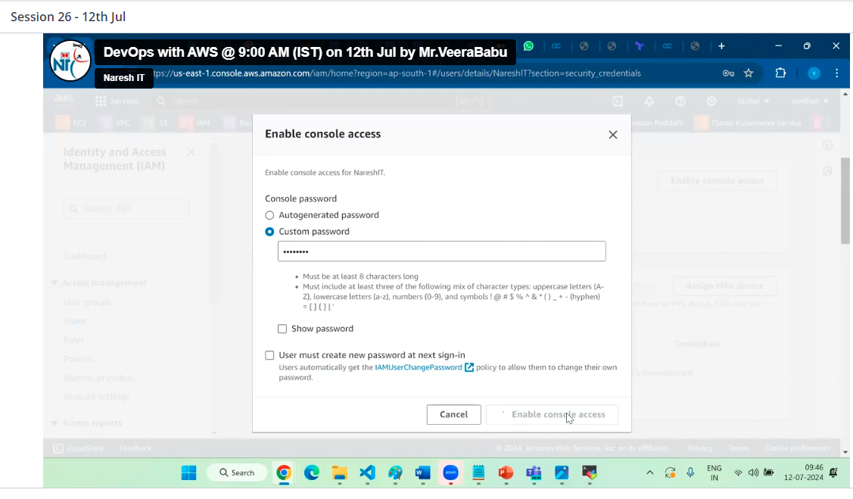

Better to download. cse file before close only for further reference

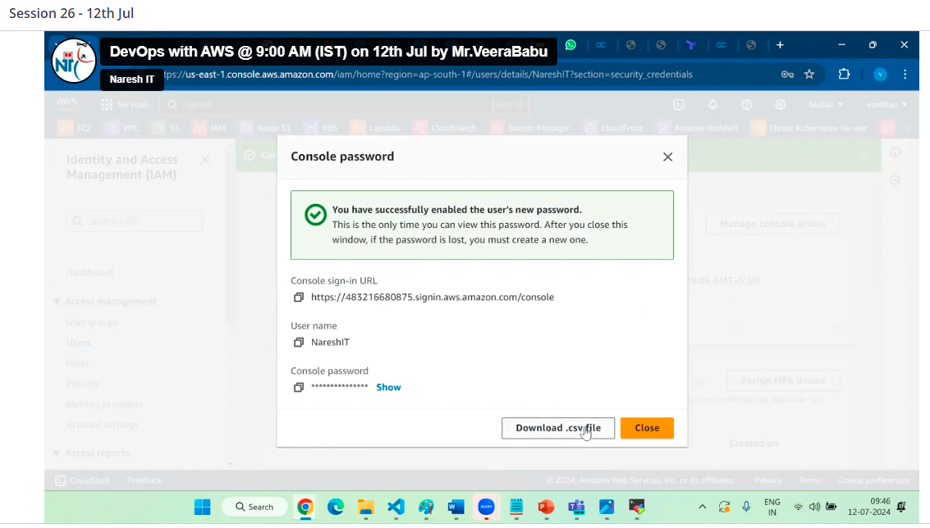

Then give the url and password to your friend to access as IAM user

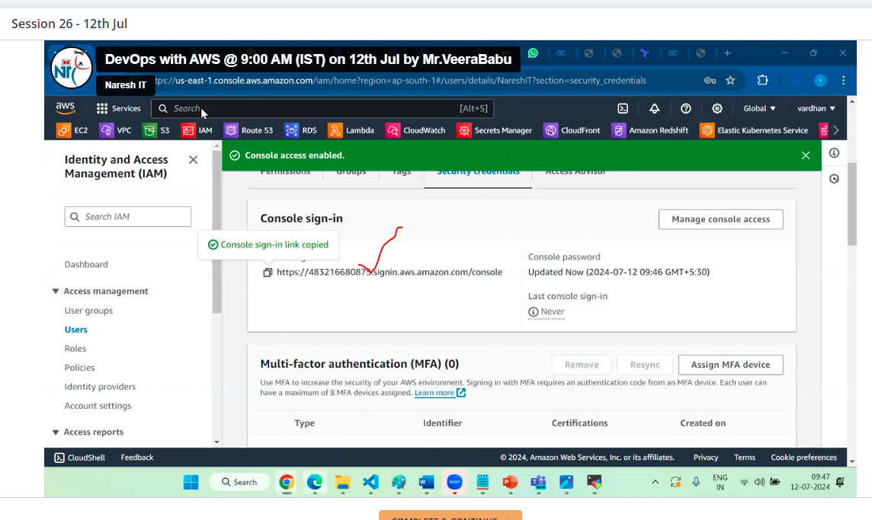

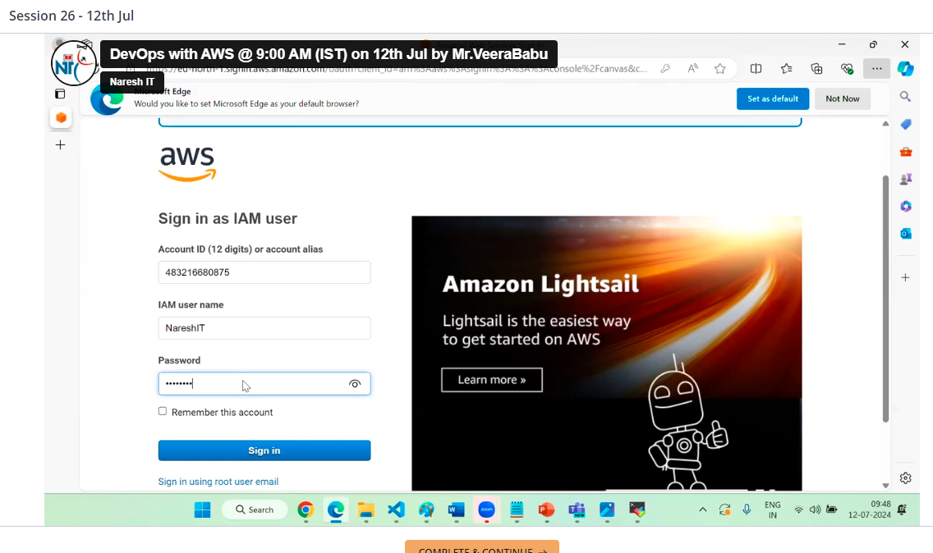

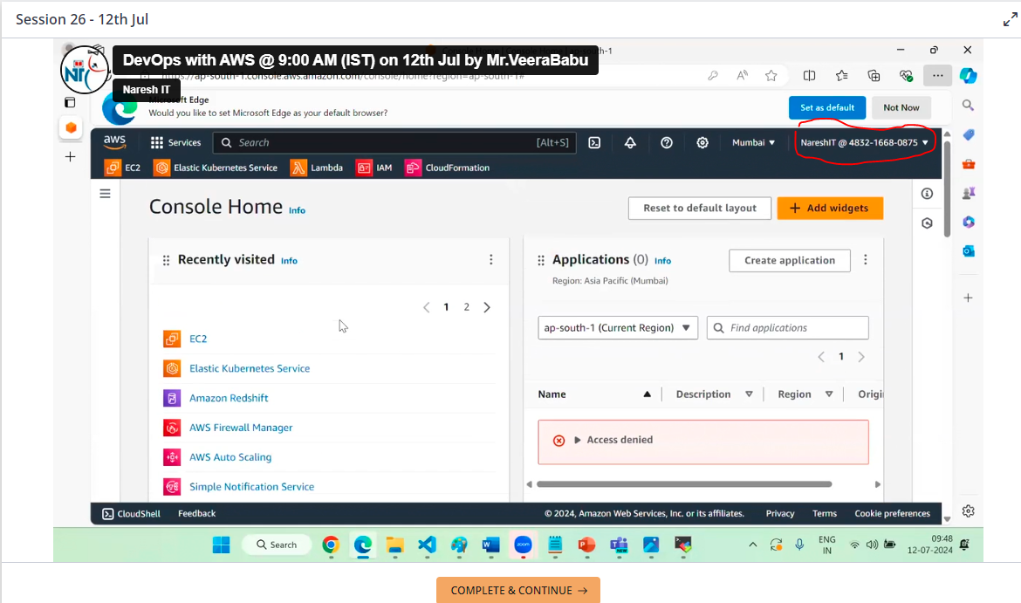Now this is IAM user

Fine grain access is nothing but only specific access (for example only 1 ec2 instead of all ec2)

In this case, we can go with custom policies

In first approach is console approach

Second approach is CLI for this we should need AWS CLI download to interact CMD prompt windows with AWS account

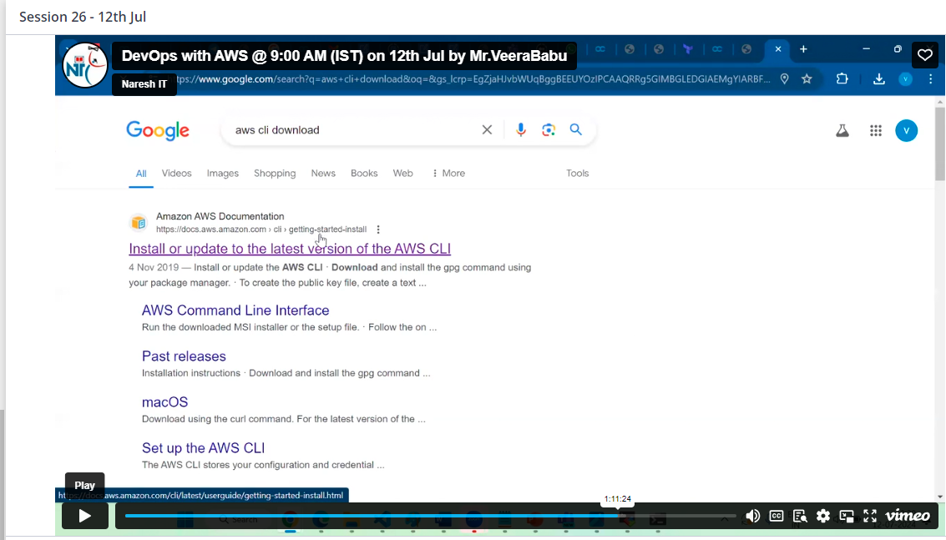

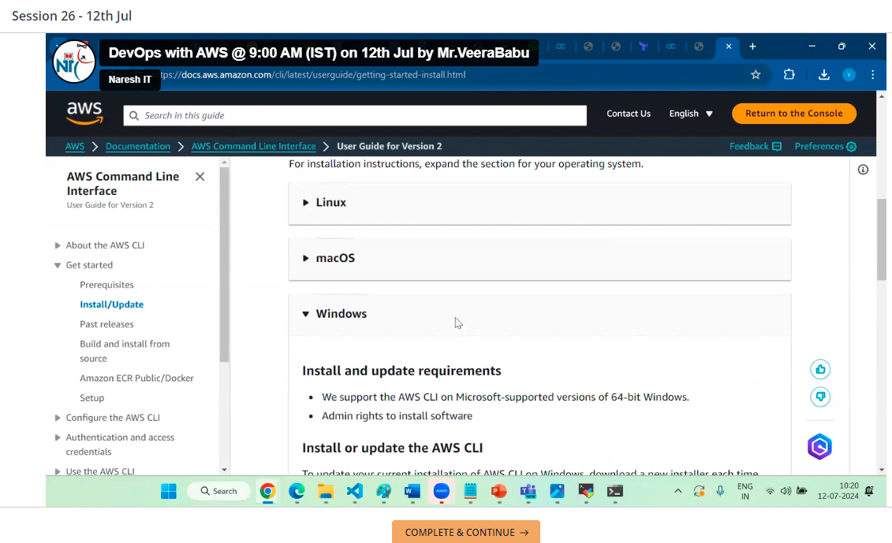

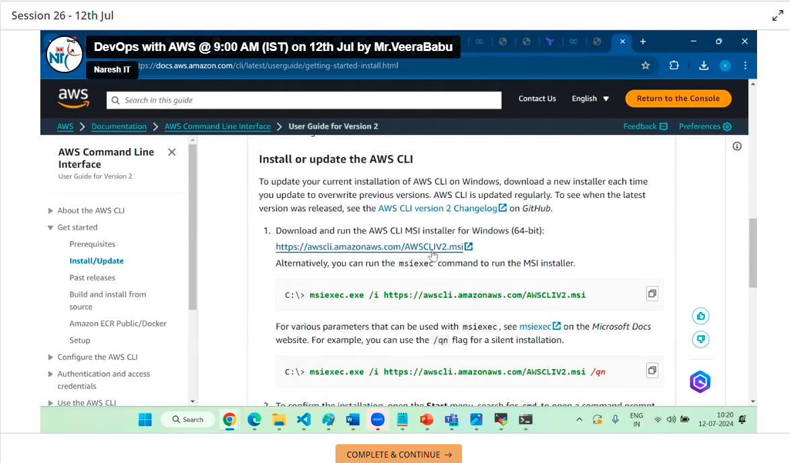

By using aws --version we can check the version of aws cli

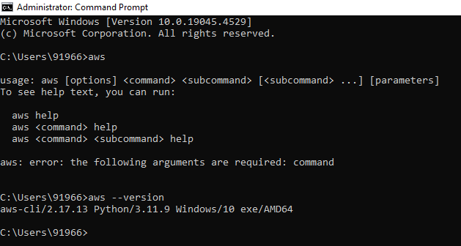

To configure AWS with CLI aws configure

Now here requires

aws configure

Access key ID

Secrete access key ID

Region

Output: json

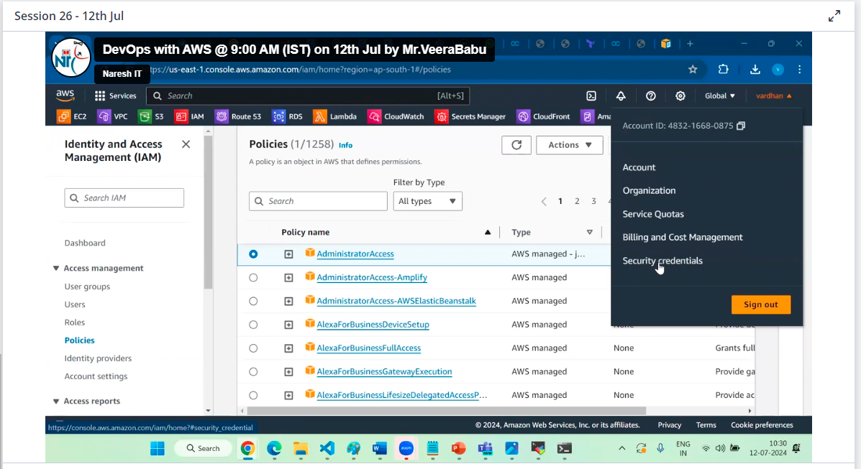

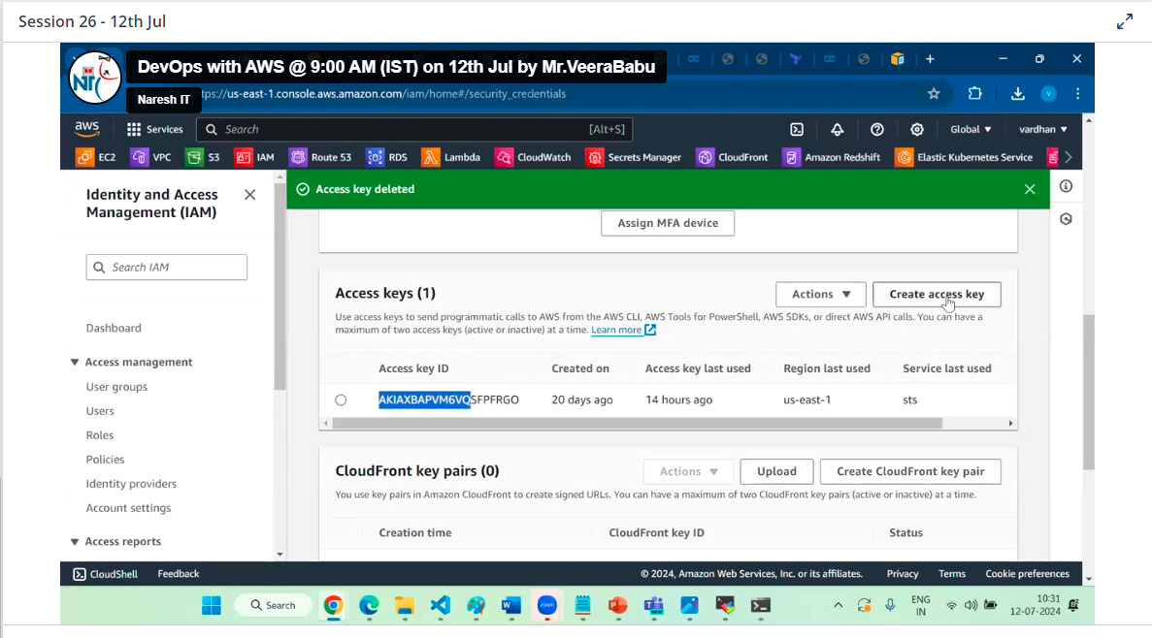

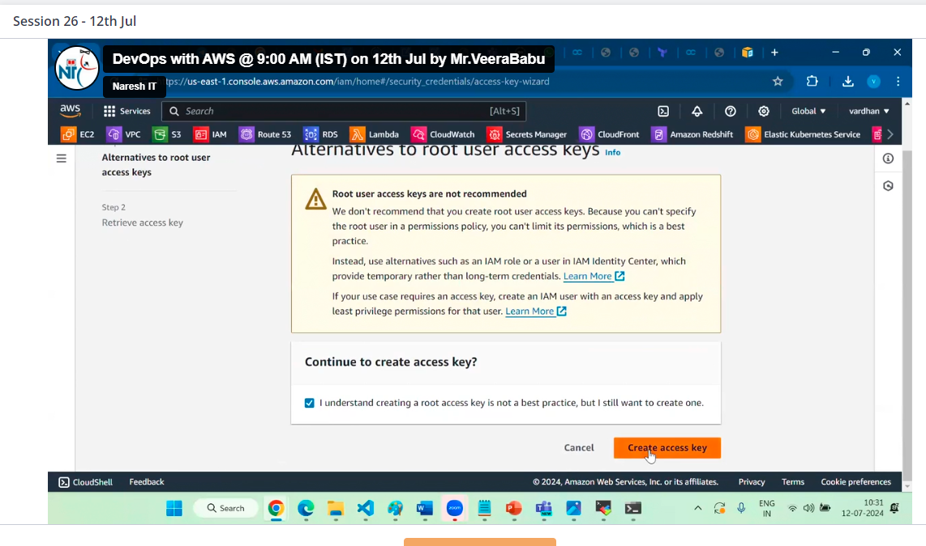

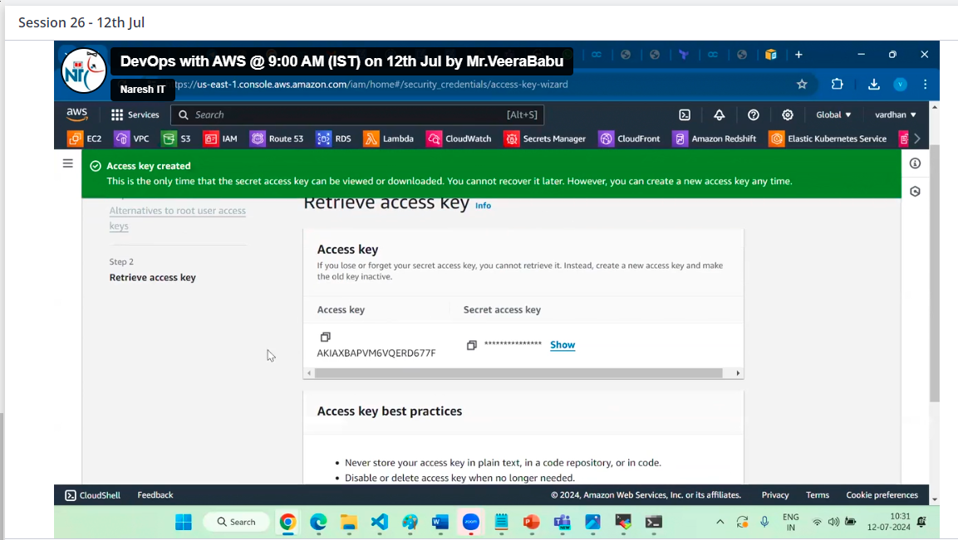

After downloaded those key in local pc

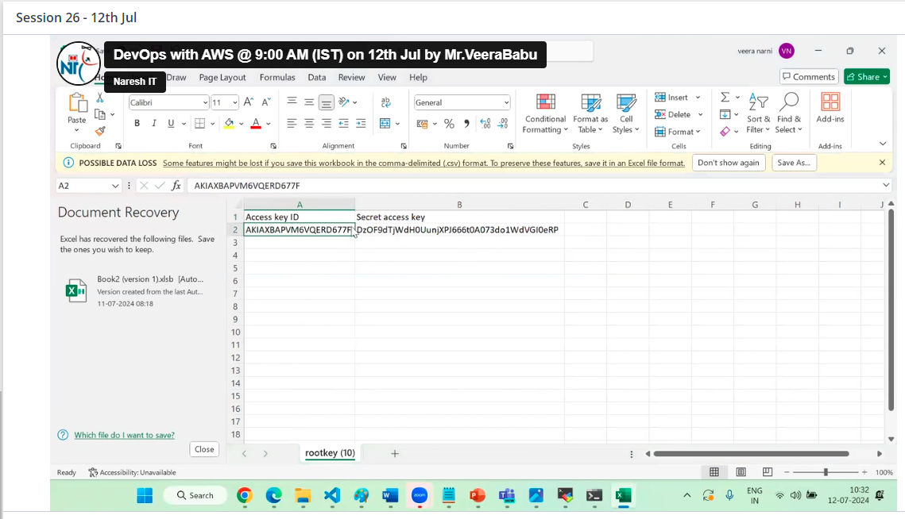

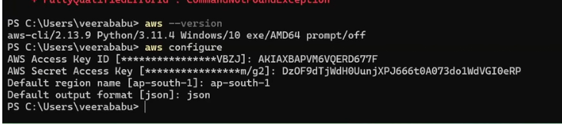

Now authentication done



To see list of ec2 instance